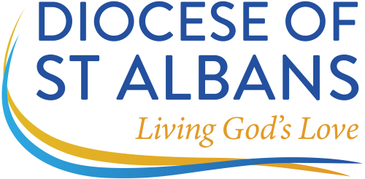

VICAR
St Mary the Virgin, Rickmansworth, WD3 1JB
SERVING THE WHOLE COMMUNITY
St Mary’s Church (Rickmansworth) is a welcoming and inclusive church with a dedicated and loyal congregation. The church is located in the centre of Rickmansworth within a 5 minute walk of the town centre. Rickmansworth benefits from excellent transport links to London via The Chiltern and Metropolitan lines, as well as beautiful surrounding countryside.
Our vision is to be a joyful church serving the whole community, and a key priority is to reinvigorate our work with young people and to expand on our existing links with St Mary’s School.
We are praying for a new vicar who will be filled with the Holy Spirit, have a heart for teaching God’s word to everyone, and who has:
- A passion for engaging with children and young people (and their leaders) to bring God into their lives and nurture their faith.
- An eagerness to work in a collaborative manner, inspiring and galvanising the whole church family, with an ability to enthuse, encourage and inspire teams of volunteers.
- The ability to connect with, and be approachable for, people from a wide range of ages and backgrounds.
- A willingness to embrace and develop our middle of the road style of worship and teaching, which is firmly rooted in the Bible and combines an appreciation of tradition with friendly informality.
We have to offer
- an active, warm and committed church family.
- a beautiful church building that is a local landmark.
- local housing in a diocesan property in Church Street, Rickmansworth, whilst a new vicarage is built.
For an informal conversation and application details please contact the Bishop of Hertford
(bishophertfordpa@stalbans.anglican.org or 01438817260)

For an application pack please contact Mrs Shirley Lee (PA to Archdeacon of St Albans): Tel 01727 818126 Email archdstapa@stalbans.anglican.org

For details of this vacancy including the parish profile, please visit the diocesan website www.stalbans.anglican.org/diocese/vacancies
Closing date for applications: 10th MAY 2023 at 12 noon
Interview date: 7th JUNE 2023
Appointment to this position is subject to satisfactory enhanced disclosure via the Disclosure and Barring Service.

