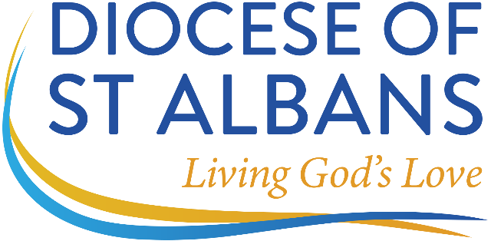

Vicar
Parish of Norton, Letchworth Garden City, Hertfordshire
Do you feel God is calling you to a lively, Eucharistic based parish where the congregation considers being Christ-centred is most important?
We are a dynamic congregation which is developing as a group who support people at whatever their stage of faith, as well as desiring to be a beacon in the local community. The church runs a range of groups for all ages from our mid-week toddler groups to our all-age bible studies.
We desire to have God's chosen leader at our head and are therefore praying for someone who has a heart for parish life, a strong faith and prayer life who can lead and encourage the changes we need in our parish and has:
- The ability to connect with, and be approachable for, people from a wide range of ages and backgrounds.
- An eagerness to work in a collaborative manner, inspiring and galvanising the whole church family, as happy to motivate as a team leader as to roll up their sleeves and join in.
- A priest with an authentic heart for God and this community who will build on where we are and bring new ideas so that everyone, children and families, single people and those who are growing older, can be challenged to respond to our living God and learn how to grow in their faith.
- A willingness to embrace and develop our varied traditions of worship and teaching that is firmly rooted in the Bible whilst not afraid to challenge conventional understanding.
- Enable our church to be a hub for the community a place where all are welcomed, feel comfortable and safe. A place that offers hope and support to all.
We offer a dedicated and committed ministerial team with friendly and supportive PCC as well as:
- an active, warm and committed church family.
- a modern church interior that is welcoming, attractive and encourages joyful worship.
- a vicarage and extensive garden adjacent to the church.
For full details of this vacancy including the parish profile please visit the diocesan website:
www.stalbans.anglican.org/diocese/vacancies or parish website at http://www.parishofnorton.org.uk/

For an informal conversation or application details please contact the Archdeacon of St Albans Office at archd@stalbans.anglican.org tel: 01727 818121

Closing date for applications: Tuesday, 23rd January 2024 at 12 noon
Interview date: Monday, 12th February 2024
Appointment to this position is subject to satisfactory enhanced disclosure via the Disclosure and Barring Service.

