Template for document accompanying a church heating application – CBC Advice

Under the Faculty Rules Update from July 2022, any relevant proposals must have had due regard to the Church Buildings Council’s Advice on Net Zero Carbon, available at: https://www.churchofengland.org/resources/churchcare/net-zero-carbon-church
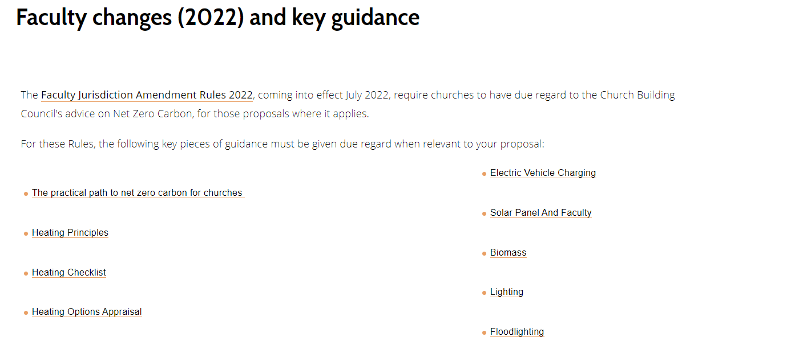
Before working your way through this template, please take a good look at all the guidance available from the Church Buildings Council.
What were the key things you took away for your church from the CBC’s guidance?

What options have you considered to heat the church in a low-carbon way either immediately or in the future? [Including whether you have received any professional advice]

What other actions have you taken/plan to take following the Practical Path to Net Zero Carbon? [You may have also submitted a copy of the Path as a supporting document]

What is your PCC’s plan to move towards Net Zero Carbon?

How does the current proposal contribute towards the PCC’s Net Zero plan?

