MMDR Form N

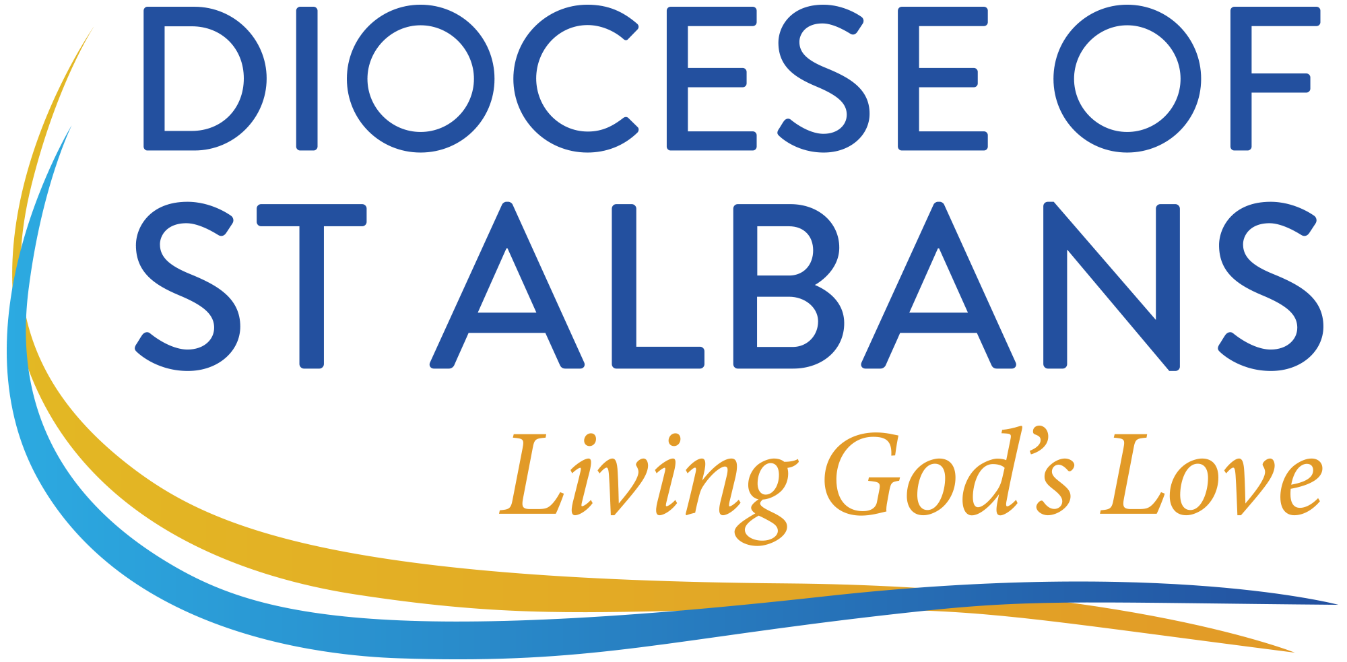
Diocese of St Albans
Mission & Ministry Development Review
Local Context Reviewer Nomination Form
Name:
Date:

Please obtain the agreement of three people – or four, if you are in a complex role – to act as Local Context Reviewers. The choices are entirely up to you; however, we recommend that you don’t choose your closest friend or colleague, nor do you choose the person whom you find most difficult. Many clergy find it helpful to ask one or more of: an ordained colleague, a Reader, a younger or older person, or someone on the fringe of the church; for SSMs especially, we suggest you may consider asking somebody in a setting, either work or voluntary, outside of the church. We encourage Local Context Reviewers not to write things that they would unwilling to say to you in person.

On receipt of this form the administrator will send Local Context Review Form P to each nominated person, together with a requested return date.

In respect of the boxes below, ‘Relationship to you’ might be: churchwarden, PCC member, parishioner, neighbouring clergy colleague, head teacher of the church primary school, etc.

Person 1
Name:
Relationship to you:
Email address:
Phone number:

Continued on page 2
Person 2
Name:
Relationship to you:
Email address:
Phone number:

Person 3
Name:
Relationship to you:
Email address:
Phone number:

Person 4
Name:
Relationship to you:
Email address:
Phone number:

Please return this form to the MMDR & Wellbeing Administrator.

