MMDR Form R

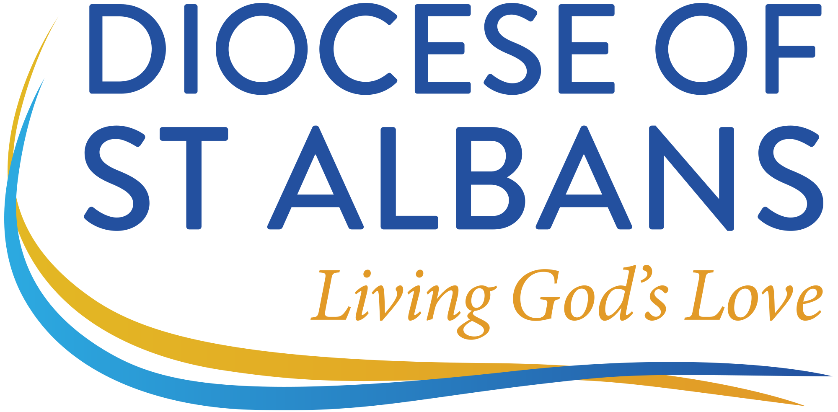
Diocese of St Albans
Mission & Ministry Development Review
Minister’s Record of Review

Please complete this first box and Question Nos. 1 to 6 three weeks prior to your review meeting and return the entire form to the administrator, who will forward it to your MMDR Consultant. Questions 7 to 13 will be completed in collaboration with your consultant, and the whole form must be confirmed as agreed before submitting the final version to the administrator.

Name:
Post / Role:
Place of Ministry:
Phone Number:
Email Address:
Website(s):

Name of Consultant:
Date of Review Meeting:

Please read the Guidelines – MMDR Document G – before continuing

Questions 1 to 6 should be completed before your review meeting

Context

1. Please give a brief description of your role. What are your main priorities and responsibilities? Which activities take most of your time? Who are your colleagues? If you have had a previous MMDR, please highlight any changes.

Review of the Previous Two Years

2. (a) If you have had a previous MMDR in this diocese, how have you got on with meeting your objectives and training needs? (b) If you have had a meeting with a member of Bishop’s Staff, what issues were raised that need to be discussed at this review?

3. As you “rekindle the gift of God” (2 Tim 1.6), in what ways have you been growing personally, professionally, intellectually and spiritually? It might be helpful to think about your skills, experience, knowledge, learning and depth of faith.

4. What have you found good and rewarding in your ministry, and why?

5. What have you found difficult and challenging in your ministry, and why?

Looking Ahead

6. What would you like to be different about your ministry in two years’ time? In five years’ time?

Please confirm that before starting the MMDR meeting you (the consultant) have conducted a Risk Assessment and it is safe to continue. (Please refer to the Diocesan website for a Personal risk assessment tool).

Questions 7 to 13 should be completed with your MMDR consultant

7. What objectives would you like to set for yourself and your ministry context? (The number of objectives will depend on your context. However, it is probably best to have around three objectives.)

8. How do your objectives relate to your Mission Action Plan (MAP) and the themes of Living God’s Love?

9. What training and development will you need? (If the answer is “none”, please give your reasons.)

10. As well as SIM (Support in your Ministry), the Diocese is able to offer you various kinds of assistance including coaching, mentoring, work consultancy, spiritual direction and group-based “action learning”. What kind(s) of support would you like to take up?

11. Please describe how you will keep your objectives and training under review. With whom will you share these objectives and training needs? Who will support and motivate you in achieving these objectives?

12. In the light of this review, are there any comments you would like to make? To whom?

Box 13 is for your MMDR consultant

13. In the light of this review, are there any observations you, the consultant, would like to make? You may wish to record briefly particular comments made by the local context reviewers.

Having completed this form, both minister and consultant should append their names to signify agreement. The minister should keep a copy for his/her records.

Minister’s name (accepted as signature):

Consultant’s name (accepted as signature):

Date completed form agreed:

Please return this form to the MMDR & Wellbeing Administrator.

