MMDR S
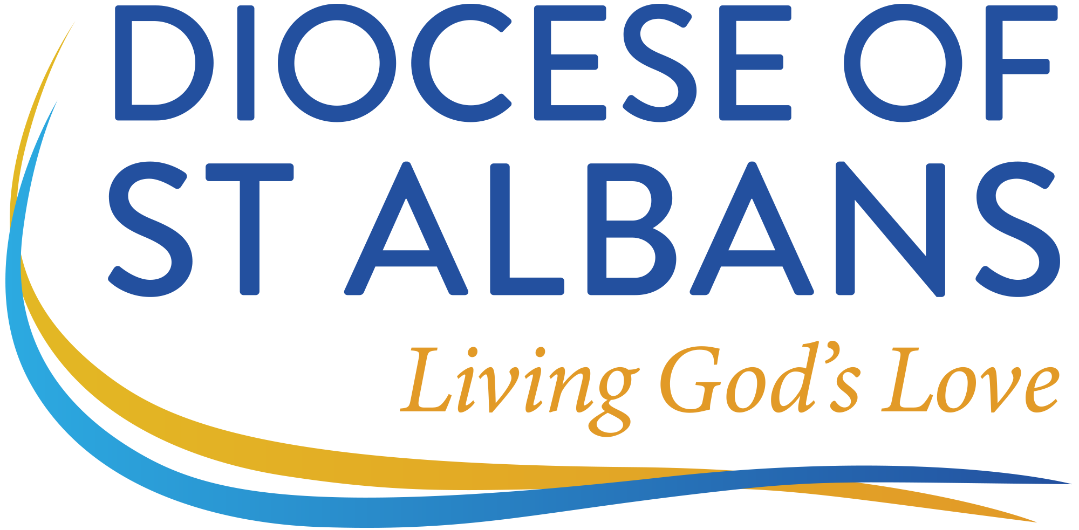
Diocese of St Albans
Mission & Ministry Development Review
Scope and Purpose of the Interim Review

The purpose of a Mission and Ministry Development Review is to look back and reflect on what has happened over the last year or two of ministry and, informed by that, to look forward to plan, anticipate and develop a clearer vision for what lies ahead. In looking back there is an opportunity to acknowledge all there is to be thankful for and anything that is a matter for lament, and in looking forward to anticipate the changing demands of the role, identify future objectives and areas for potential development.

In St Albans Diocese, the Bishop anticipates that this ‘looking back’ and ‘looking ahead’ will be done in the context of Living God’s Love.

Living God’s Love is the vision of the parishes, church schools and chaplaincies across Hertfordshire, Bedfordshire, Luton and Barnet. This Vision is grounded in our love of God and love for neighbour flowing from God’s love for us. Its three priorities are going deeper into God – transforming communities – making new disciples. Using Mission Action Planning (MAP) we are developing confident and outward looking mission leading to spiritual and numerical growth.

It is therefore hoped that both ministers and Bishop’s Staff will see MMDR as a means of reflecting on these themes. The Interim Review differs from the MMDR in five important ways:

- Because of the highly-valued and important role that the Bishop’s Staff have in pastoral oversight, this will play a more significant part in the Interim Review.

- Unlike the MMDR this Interim Review will take into account not only the individual, but also the wider context of the person’s ministry. It will, therefore, look (where appropriate) at the parish MAP and at the Statistics for Mission.

- The Interim Review will enquire specifically about any goals that the minister set in the previous MMDR, and about any training that he/she committed him/herself to undertake.

- The Interim Review will pay more attention to the person’s vocation in its wider context. There will, for example, be an opportunity to discuss whether, and if so, when, a change of role might be appropriate.

- Since it is of great importance that we take safeguarding seriously at every level, the Interim Visit will consider any safeguarding issues in your situation.

In order to give some structure to the Interim Review, the member of the Bishop’s Staff will cover the five areas listed above. Ministers may find it helpful to have given some thought to these areas prior to the Interim Review by considering the questions below. No written response need be produced in advance, although ministers may find it helpful to note down some key points. At the end of the review, it is considered good practice to record any outcomes on MMDR Form T.

Questions for Consideration at an Interim Review

- Think about your own well-being: physical, mental, social and spiritual. In what ways have you flourished as a disciple of Christ, and in what ways have you struggled?

- Think about our shared mission of Living God’s Love and its three strands: going deeper into God, transforming communities and making new disciples. In the light of this, what reflections do you have on your MAP and Statistics for Mission (where appropriate)?

- Look back at your last MMDR. In what ways are you achieving the objectives that you set, and which objectives are proving more challenging?

- Think about the entirety of your ministry. Where do you feel that God might be calling you in the years to come? What stepping stones will help you get there?

- Think about Safeguarding. What is your current situation regarding your own training, your safeguarding policy, any on-going issues and any “covenants of care”?

