MMDR Form T
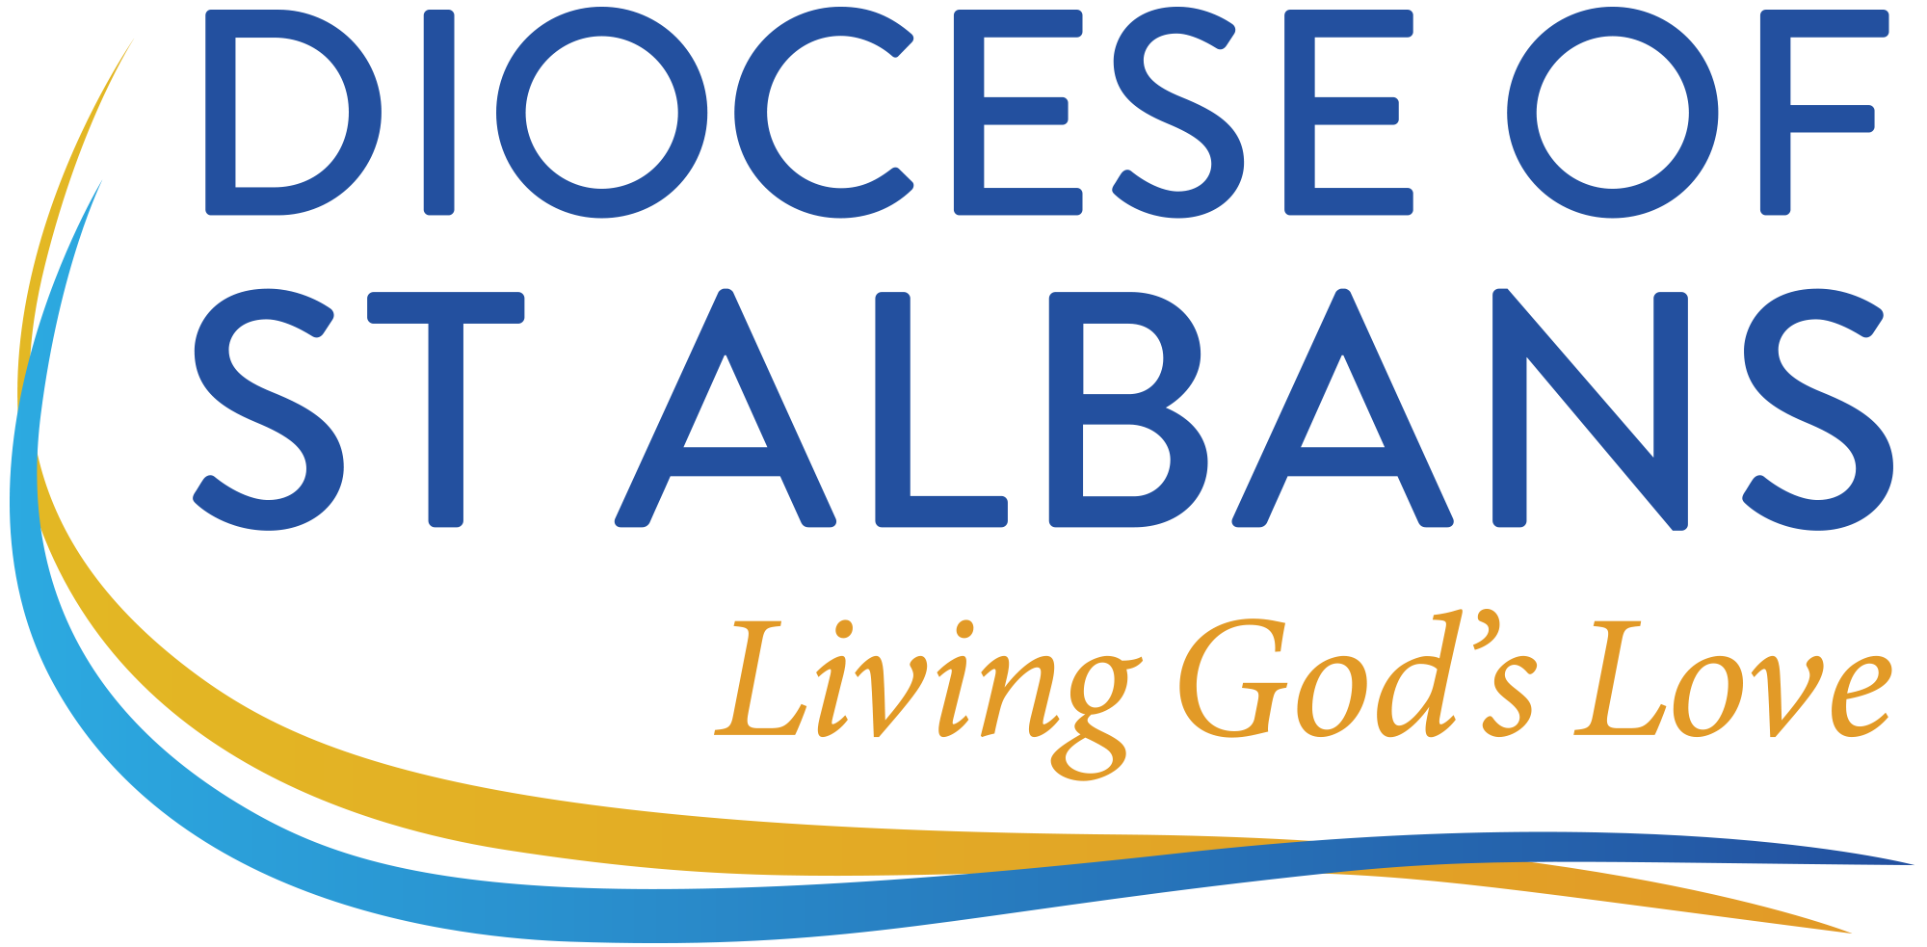
Diocese of St Albans
Mission & Ministry Development Review
Interim Review Outcome Form

It is recommended that this form is completed at end of an Interim Review with a member of
Bishop’s Staff.

Name:
Phone Number:
Email Address:

Post / Role:
Place of Ministry:

Date of Interim Review:

Please list the outcomes and decisions made at the Interim Review, noting any matters raised in response to Question 5 concerning safeguarding. What are the key points which were agreed by both the minister and the member of Bishop’s Staff?

Having completed this form, please retain a copy for discussion at the next MMDR

Minister’s name (accepted as signature):
Bishop’s Staff Member’s name (accepted as signature):

Date completed form agreed:

