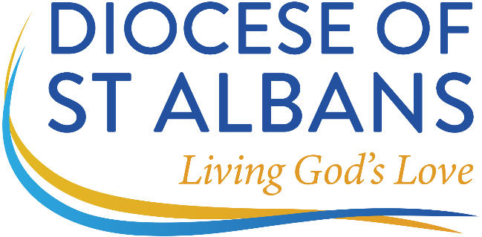

APPLICATION FOR PERMISSION TO OFFICIATE IN ST ALBANS DIOCESE

Contact Details

Name:

Address:

Contact Phone Number:

Email:

Date of Birth:

Are you Retired? Yes/No Are you in receipt of a Church of England pension? Y/N

Existing and Previous Ministry

Are you currently beneficed, licensed or employed under contract in another diocese?

If so, please give details of diocese and post:

Do you currently hold PtO in another diocese or dioceses?

If so, please give details:

Please give details of any PtO granted in other diocese which is no longer current:

Please give details of any application for PtO that has been refused, along with the reasons why:

Safeguarding Information (In accordance with national guidelines, the Bishop of St Albans is unable to grant PtO unless all safeguarding training is up to date)

Please give completion dates for the following courses:

C0 (Basic Awareness)

C1 (Foundations)

C2 (Leadership)

S3 (Awareness of Domestic Abuse)

Date of last DBS check:

Ministry Intentions

Please specify which parish you wish to be attached to:

How are you hoping to use your PtO?

Declarations

I acknowledge that, in accordance with Canon C1, I owe canonical obedience to the Bishop of St Albans and their successors in all things lawful and honest.

I understand that it is my responsibility to inform the Bishop’s office of any changes in my personal details.

I understand that I must not officiate without the permission of the relevant incumbent or priest in charge.

I understand that PtO is granted at the discretion of the Bishop and may be withdrawn at any time.

I understand that PtO will only be granted if I have not been barred from regulated activity with children or vulnerable adults and my DBS certificate has been deemed satisfactory having regard to relevant House of Bishops’ Guidance.

I acknowledge that I am legally required to have due regard to the House of Bishops’ Guidance in relation to the safeguarding of children and vulnerable adults and I will accordingly undertake such safeguarding training as the Bishop requires.

I understand that the Bishop’s Letter of Authorisation, if granted, will specify the length of time for which I may exercise PtO and any relevant geographical restrictions, after which I must apply for renewal.

If my PtO has lapsed for any reason, I agree that I will not undertake any forms of ministry until all matters have been resolved.

Fees and Occasional Offices

I understand that I may be able to receive to fees for funerals and weddings in certain circumstances in accordance with Diocesan guidance. Fees outside this guidance must be paid in full to the relevant DBF and PCC and that it is not lawful for me to retain any part or whole of the fees that is payable to the DBF and the PCC without the agreement of the DBF and PCC.

Further information about payments of fees to clergy with PtO can be found on the diocesan website.

I understand that, as a clerk in holy orders, I may only use the forms of service authorised by Canon and may not exercise ministry on a freelance basis or take funerals (or accept fees for taking funerals) in a private or unofficial capacity.

Signed: Date:

Personal Data Declaration
Personal data will be handled in accordance with GDPR guidelines

Declaration by Incumbent/Priest in Charge/Rural or Area Dean

Name:

Having discussed this application with (………….……..….name of applicant…..….……………), I commend this application to the Bishop of St Albans.

Signed: Date:

(Incumbent/Priest in Charge/Rural or Area Dean)

Please return the completed form to Deborah Hoare at Abbey Gate House (dhoare@stalbans.anglican.org)

