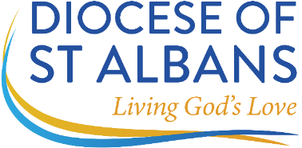

ANNUAL MINISTERIAL RETURN – PTO CLERGY
Please return the completed form to Deborah Hoare (dhoare@stalbans.anglican.org)
This form is intended for brief discussion – please do not worry if you cannot complete all boxes.

Name:

Parish:

Designated Person Responsible for Oversight:

Ministry carried out for the period from ………………….…………..….....……………. to ……………..………..…..……………..…….……….

If the ministry is primarily parochial, please list the approximate number of occasions below during the year when you have:

 | In My Own Parish | Other Parishes
Presided at the Eucharist

Preached

Taken Funerals

Taken Weddings

Provided Teaching (bible study, confirmation preparation)
Carried out Visits and Provided Pastoral Support
Other (please specify)

In addition to my own parish I have provided ministry in the following parishes with the permission of the Diocesan Bishop and relevant incumbent/priest in charge.

I have also provided support for the diocese in the following ways during the period stated overleaf.

Any further comments, including change in circumstances which you would like the archdeacons and bishops to know.

I discussed my ministry with …………………………………………….…….………………….. on ……………….…….…………………………… and

⃝ no change was made to the agreed expectations of ministry

⃝ agreed expectations of the ministry I am to carry out were changed and a copy is attached.

Signed: …………………………………………………………………………………………………………………. Date: ……………………………………………
(With PtO)

Signed: …………………………………………………………………………………………………………………. Date: ……………………………………………
(Designated Responsible Person)

Position: ……………………………………………………………………………………………………………………………………………………………………….

Date of Next Return:

