

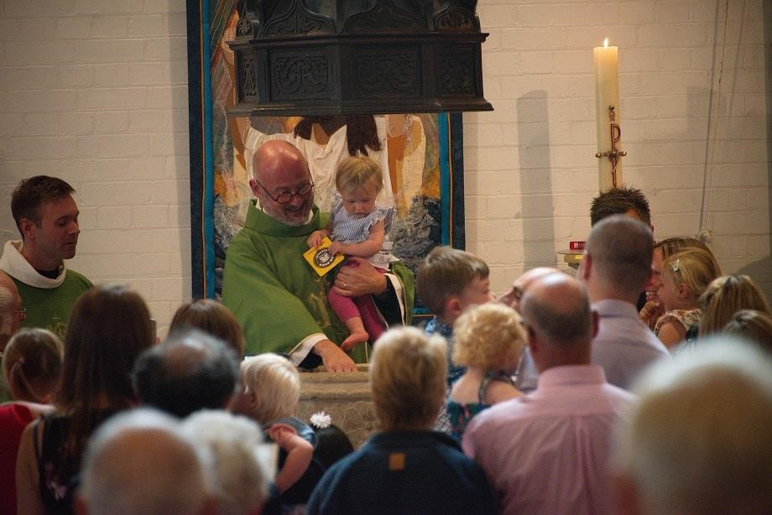

Our Vision
BROADER VISION / GREATER IMPACT / GROWING CONGREGATION

Our Values
We are a welcoming and inclusive Christian community
built on the understanding that God accepts us equally, irrespective of gender, sexuality, race, social standing, belief, age or ability - and believing that God calls us equally to share that unconditional love with all people,
without exception.
Thank you!
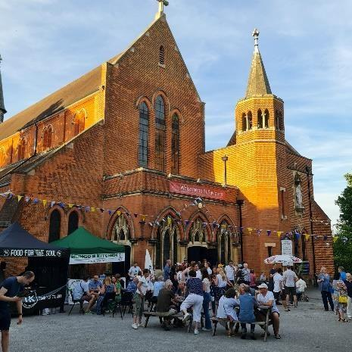
for considering the role of Children and Families Lead at St Saviour’s. We are a busy parish church in the Bernards Heath area of St Albans, increasingly finding our place at the heart of our local community. We offer an inclusive welcome and are open to all.

History
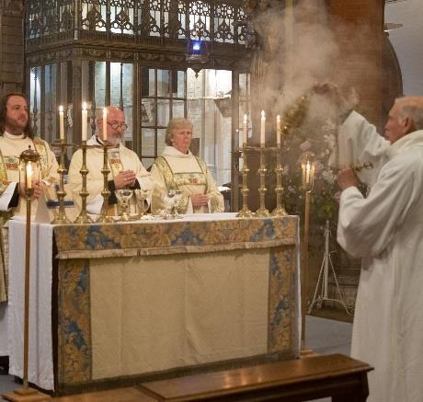
St Saviour’s started as a small iron building, just around the corner from its current location, and was a Mission Plant by the neighboring Parish of Sandridge. After land was gifted by Earl Spencer on Sandpit Lane, construction of the current church building started in July 1896. Six years later, in 1902 the completed church was dedicated by the Bishop of Colchester on All Saints' Day. Most of the bricks used in building the church were from the local brickyard, and the church was known as the ‘Cathedral of the Workers’.

Worship
St Saviour's has always been in the Anglo-Catholic tradition of Anglican spirituality and worship. This means we use ritual and ceremony to express those things which go beyond words; and try to provide a space in which each of us can encounter Jesus, especially in the words of Scripture and the bread and wine of Communion at the Sunday Mass. However, in addition to our main Sunday services, we also offer informal worship and are open to new initiatives.
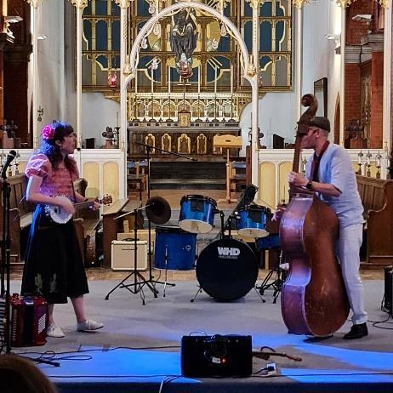
We run a monthly, non-eucharistic family event called ‘Families at Four’ - a mix of storytelling, music, crafts, games and outreach, that ends with a simple shared meal. We also run a monthly informal communion service, using alternative liturgies, art and contemporary music.

Events
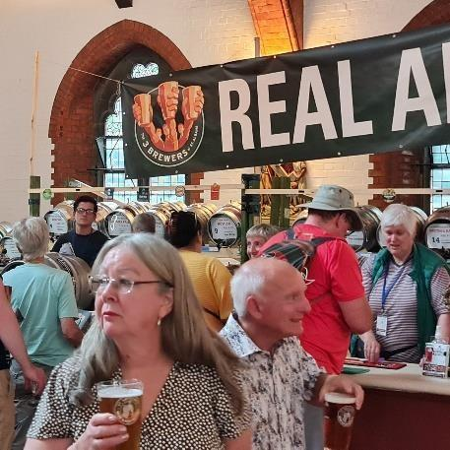
Over the past 8 years we have increased our community engagement through opening the church up for a variety of events. Every summer we organise a three-day beer festival, which attracts thousands of people from across Hertfordshire and London, with beer, live music and a very busy family day! Once a month on a Friday evening during the summer, we host Street Food Heroes, a collective of street food vendors who draw a good number of families and others from the local area. In the autumn we organise a two-day Harvest festival, with live music, stalls and activities for families. Throughout the year we host a variety of other events too, including Jazz evenings, classical concerts and barn dances.

Vision
St Saviour’s is at an exciting point in its journey. We are committed to several priorities within our Mission Action Plan; one of these being to “Grow younger and more diverse”. As part of the Ministerial Team, the Children and Families Lead will play a key role in supporting St Saviour’s in this important priority and develop existing and new ways of engaging children, young people and families, helping them to explore the love of God and to encourage them on a journey of faith.

Children and Families Lead
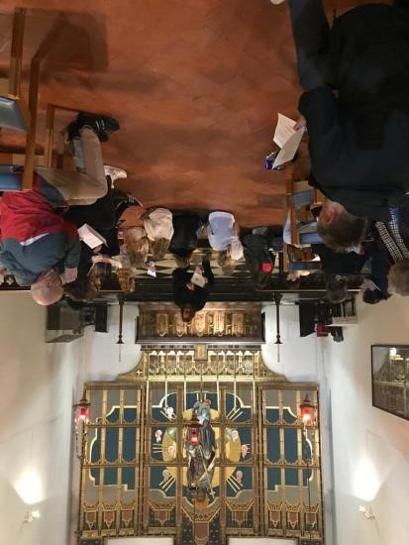
The Children and Families Lead will work closely with the parish clergy and our team of committed volunteers to support the ministry to children and young people across the parish. This will involve working in partnership with people from our congregation, as well as engaging with agencies and individuals in the wider parish, including schools and uniformed organisations.

Congregational growth is at the heart of our mission and ministry, and our 2026 Mission Action Plan recognises the importance of growing younger and more diverse. This new role is a significant step in developing this work. This position will oversee existing groups and activities, including our Sunday provision, as well as developing new opportunities for children and young people to engage with the Christian faith and the life of the church.

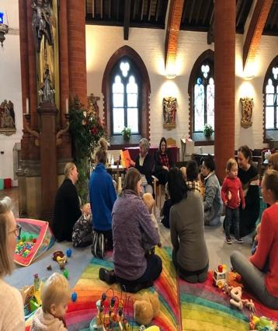
The Children and Families Lead will enjoy working with young people of different ages, and feel equally at home at a toddler group, teenage Bible study, or running a youth group. There is a strong musical tradition at St Saviour’s which presents opportunities to develop the involvement of young people in the musical life of the church.

The role will involve offering an appropriate level of pastoral care, so you will need to be intuitive and insightful, with experience of working with young people and responding to their needs. You will be key in building relationships, not just with children and young people, but also with their families, and helping them integrate into the wider life of St Saviour’s. The responsibilities are varied and, although we recognise there is a necessary element of administration, this is primarily an opportunity to work “hands on”.


There is scope for flexibility in the pattern of working hours, depending on the successful candidate’s availability, and we are keen to explore a realistic working pattern. However, it is anticipated the successful applicant will work an average of 18 hours a week over the course of the year with slightly more hours being worked during term time, when groups are active, and fewer hours in the summer holidays, with some additional hours worked to support seasonal periods e.g. Christmas and Easter.

This role includes regular Sunday working and reports to the Vicar and Parochial Church Council. There is significant opportunity for this exciting role to be shaped by the successful candidate. It promises to be a rewarding ministry with the potential to make a meaningful difference in the present and future next stage of mission and ministry at St Saviour’s.
Key Responsibilities

The main duties and responsibilities of the role are outlined below. This list is not exhaustive and is instead intended to reflect the main tasks and areas of work.
- Develop and oversee the teaching, worship and activities for Sundays at Ten and Families at Four.
- Assist in planning and leading our monthly All-Age service.
- Work alongside clergy to deliver assemblies in our local non-church primary school.
- Assist in the pastoral provision for children, young people and families, alongside the clergy.
- Oversee the running of Tots Time (our weekly pre-school group)
- Involvement in baptism prep/confirmation classes.
- Explore opportunities for a youth group/after school group - potentially introducing children’s activities alongside monthly Street Food Heroes event.
- Work with volunteers to deliver Easter and Christmas children’s events.
- Maintain accurate administration records for the various groups.
- Administer relevant Social Media accounts.

Safeguarding

All staff and volunteers are expected to demonstrate a commitment to safeguarding the welfare of all children and vulnerable adults who are involved with or visit St Saviour’s. This will include adherence to policies and procedures, following good practice in relation to their own behaviour and conduct, and undertaking any safeguarding duties and training commensurate with their role. You will be required to undertake Church of England Leadership Safeguarding Training.

Our Vision

Mission Action Planning has been used in our Diocese as a tool for growth in parishes for many years now. It’s a simple and effective process to gain an understanding of a church’s mission and ministry; then establish a vision and priorities which determine a ‘direction of travel’ in order to meet the needs of the local community, as a real and tangible way of Living God’s Love.

In February 2026, members of the church community met to reassess St Saviour’s priorities, targets and goals, these are:

- Make Church & Hall fit for worship and as a ‘community hub’
- Identify new projects and partnerships to increase community engagement.
- Growing younger and more diverse

Excitingly, the successful applicant will be able to make valuable contributions to all of the above priorities. We would value their input on how they believe the church spaces can be made more accessible and inclusive towards families.
There are already many strong links between the church and the local community, but there will be opportunities to find new areas for growth and for the successful candidate to use their own particular gifts in order to work towards increasing community engagement.
Employing a Children and Family Lead is an important step towards the church “growing younger and more diverse” and will play a vital role in ensuring that all members of our church community feel valued and included.
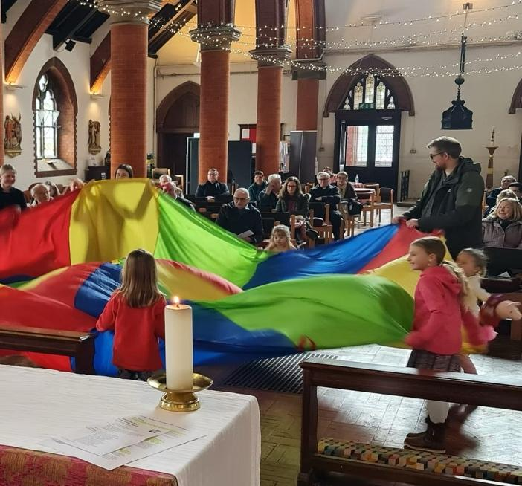
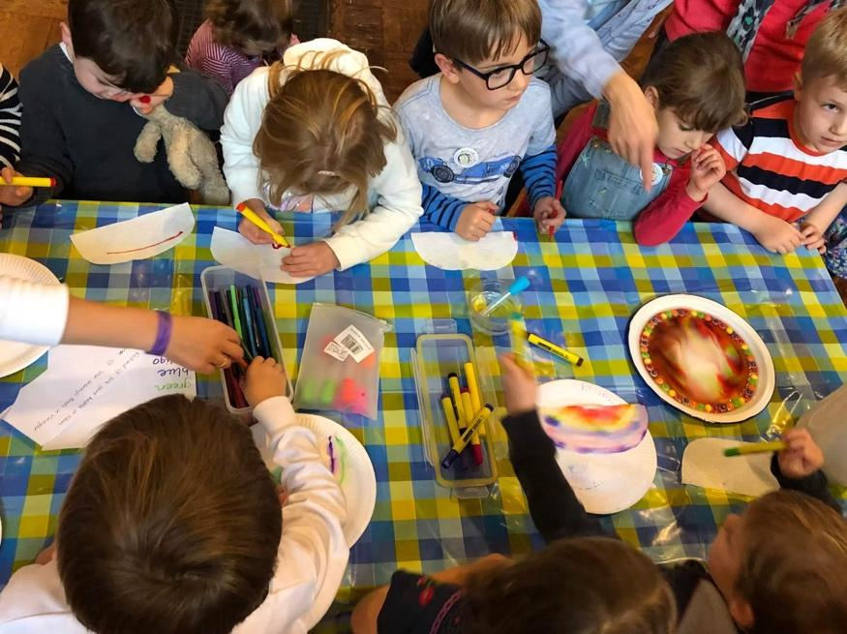

Person Specification

Essential

- Love for God and a commitment to discipling young people.
- Empathy and excitement for St Saviour’s purpose, vision and priorities.
- Ability to use initiative and be held accountable.
- Ability to work collaboratively with clergy and volunteers.
- Ability to coordinate and prioritise several initiatives and tasks at the same time.
- Desire to make valued contributions outside of your own area of responsibility.
- Ability to uphold and adhere to the requirements of St Saviour’s safeguarding policies.
- Willingness to work flexibly, including the ability to work outside of normal hours when required.

Knowledge and experience

- Proven and demonstrable experience of working with children and young people within a church/faith environment (voluntary or professional).
- An understanding of the Church of England and knowledge of church life and culture.
- A willingness to lead worship both with large and small groups of children.
- There is an occupational requirement that the post-holder is a committed Christian.

Skills and abilities

- Excellent organisational skills with the ability to plan, prioritise work and meet deadlines.
- Ability to innovate and be creative.
- Ability to initiate, develop and implement good practice.
- Ability to recruit, equip, encourage and lead volunteer teams.
- Good IT and administrative skills.
- Excellent communication skills and ability to relate well to a variety of people.

Desirable

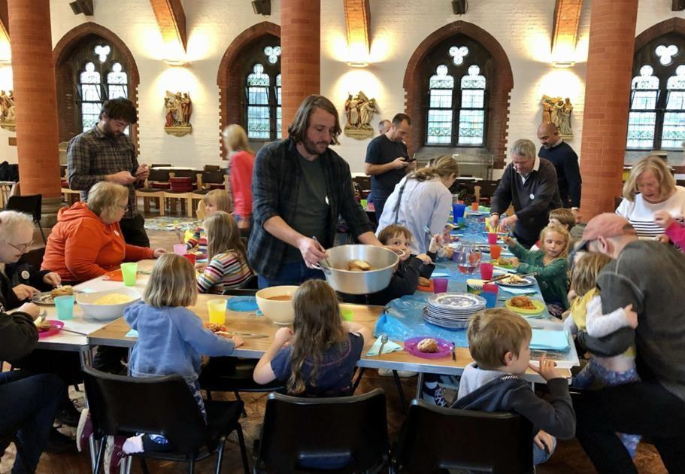
- Relevant qualifications related to children’s work/ministry,

Terms and Conditions

Hours of work: | 18 hours per week.
Remuneration: | We pay the London Living Wage, which is currently £14.80 an hour. FTE: £28,860 (37,5hrs per week)
Annual leave: | 25 days plus public holidays (this will be pro-rated based on contractual hours)
Pension Scheme: | The option of joining St Saviour’s qualifying workplace pension scheme (eligible employees will be enrolled in this scheme if they meet the Government’s automatic enrolment criteria). After any probationary period, St Saviour’s currently matches employee contributions up to a maximum of 6% of pensionable pay up to State Pension age.

The Recruitment Process

Applicants are invited to submit a CV (including the names and contact details of two referees - one personal and one professional) and a covering letter with details about why you wish to apply for the job and why you think you would be a good fit for the role. Please send these to the Assistant Curate, Emily Lloyd, at curate.stsaviours@gmail.com

We are committed to finding the “right” person for this role. Therefore, there is no current deadline for applications. Invitation to interview will be based on the suitability of your qualification, experience and abilities.

We are committed to a culture of diversity, equity and inclusion and we welcome and encourage applications from a diverse range of people. We support our staff to manage their time flexibly and to enjoy a good work-life balance.

We are committed to providing a welcoming, respectful and safe environment for all and expect all staff and volunteers to share this commitment. Our appointment processes follow the Church of England’s Safer Recruitment Practice Guidance.

Appointment is subject to:

- Two satisfactory references.
- An enhanced DBS criminal record check and completion of a confidential declaration form.
- Completion of a Medical Questionnaire.
- Confirmation of your right to work in the UK.

