Christian Environmental Action

CHRISTIAN CLIMATE ACTION

Christian Climate Action is a group within the Extinction Rebellion (XR) movement that consists of Christians who are committed to taking action on the climate crisis. They believe that caring for the Earth is a fundamental part of their faith and that Christians have a responsibility to protect and steward God's creation.

Christian Climate Action draws on Christian teachings and values to inspire and guide their activism. They believe that the Bible calls Christians to love and care for the Earth and to seek justice for those affected by climate change. They emphasize the importance of repentance, prayer, and action in addressing the climate crisis.

The group engages in nonviolent direct action and civil disobedience to raise awareness about the urgency of the climate crisis and to demand action from governments and institutions. They participate in protests, marches, and other forms of activism to highlight the moral and ethical dimensions of the climate emergency.

Christian Climate Action also works to build connections and solidarity with other faith-based and environmental organizations. They collaborate with other Christian groups, interfaith networks, and environmental justice movements to amplify their message and advocate for systemic change.

Overall, Christian Climate Action seeks to mobilize Christians to take a stand against climate change and to work towards a more just and sustainable world. They believe that addressing the climate crisis is not only an environmental issue but also a moral imperative rooted in their Christian faith.

Teaching Ideas
- Urging churches to Drop Barclays
https://christianclimateaction.org/2023/11/14/urging-church-to-drop-barclays/

As you can see from this page- CCA held protests to challenge dioceses (church ‘counties’) who put their money with Barclays bank.
Display the list of dioceses which bank with Barclays: ask the class to suggest reasons why Christians who want to protect the planet might object. Why does it matter where a diocese banks?
- Chelmsford
- Chichester
- Ely
- Gloucester
- Leeds
- Leicester
- London
- Newcastle
- Norwich
- Portsmouth,
- Peterborough
- Rochester
- St Albans
- York

Show this webpage, called ‘Banking on chaos’- scroll down to the world map. Pause to let students read the facts and figures on the second slide: https://www.bankingonclimatechaos.org/
Read the text at the top of the world map: ‘Bank funding for fossil fuels often brings dire threats to the lives and livelihoods of local communities around the world — harming Indigenous Peoples, Black and Brown communities, and poor and working-class communities first and worst’.

Ask groups to brainstorm why the CCA are trying to persuade churches not to bank with Barclays. Listen to each group’s answer.

Ask students if they expected Christians in the UK to be concerned about banks and the oil industry. What would they expect environmental Christian groups to be doing or saying? Does this focus on banking surprise them?

Bible Passages
Read and discuss these bible passages that refer to the use of money:

Matthew 6:24  "No one can serve two masters. Either you will hate the one and love the other, or you will be devoted to the one and despise the other. You cannot serve both God and money." | Luke 12:15  "Then he said to them, 'Watch out! Be on your guard against all kinds of greed; life does not consist in an abundance of possessions.'"
1 Timothy 6:10  "For the love of money is a root of all kinds of evil. Some people, eager for money, have wandered from the faith and pierced themselves with many griefs." | 2 Corinthians 9:7  "Each of you should give what you have decided in your heart to give, not reluctantly or under compulsion, for God loves a cheerful giver."

Print out an image of a £50 note, large enough to design on and hang up.

Choose a passage, write out, decorate with words and figures from the Banking on Chaos website. Use these as bunting in the classroom.

- Christmas National Gallery Protest
Members of CCA held a protest at the National Gallery in London.
These images and text are from Instagram: https://www.instagram.com/christianclimateaction/
Load up the Instagram page on the whiteboard and show students the short videos.

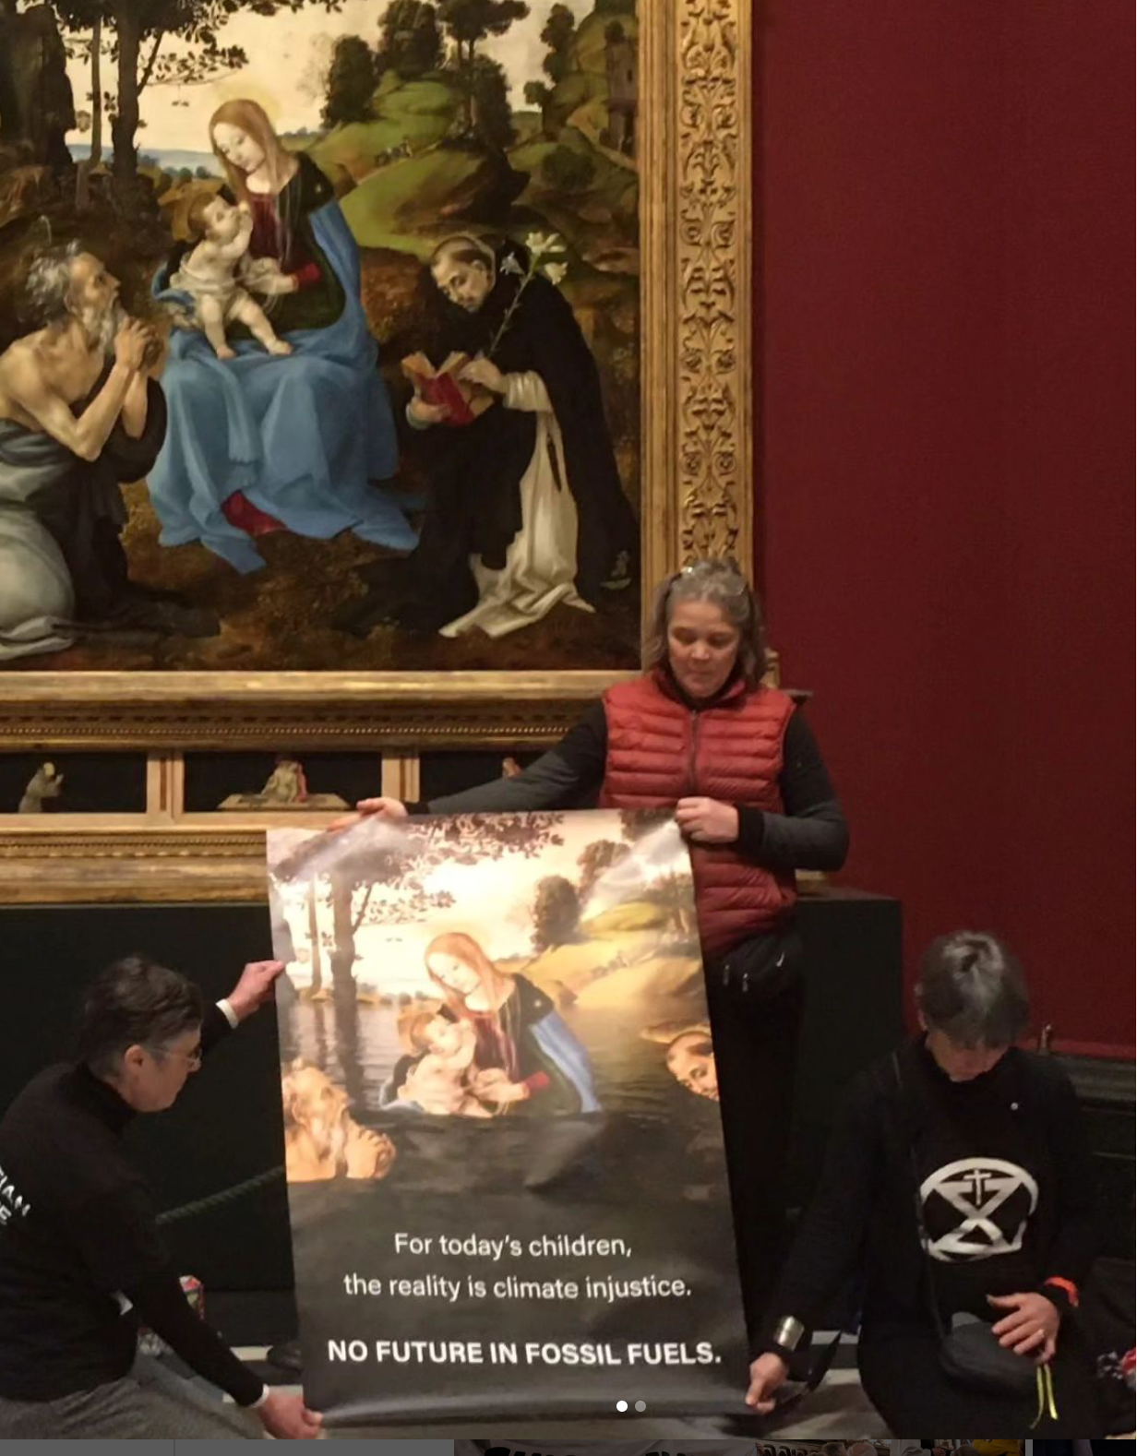 | 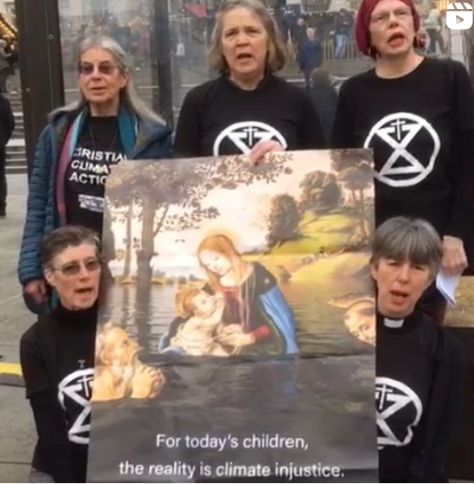
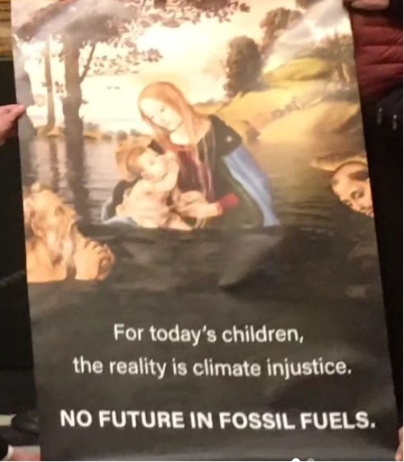 | 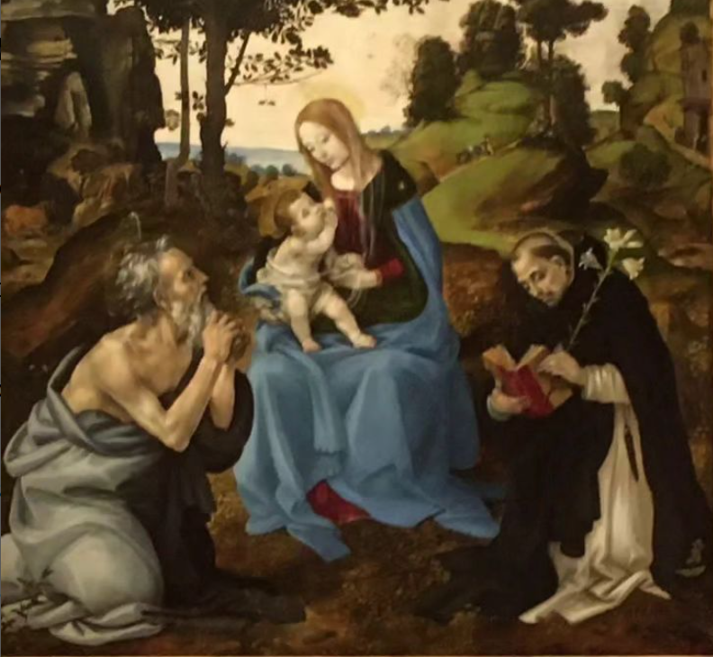
Today we were at the National Gallery.  We stood in front of a painting by Filippino Lippi called The Virgin and Child. We held an alternative version, which included a climate-ravaged landscape.  Climate change is stripping a future from young people | "Christmas is a time for children. But today, world leaders are failing them. Babies born in the Global South are most at risk of unliveable heat, hunger, drought, flooding and displacement"

The group sang Silent Night. In the letter they stated that at Christmas ‘sentiment, tradition and festivity won’t save us’. What do students think this means?

Hand out Christmas cards with traditional scenes to each group. Ask groups to collage over the scenes images of climate breakdown, pollution, loss of habitats and natural disasters.

Environmental Activism

EXCTINCTION REBELLION

Extinction Rebellion

Extinction Rebellion (XR) is a global environmental movement that uses non-violent civil disobedience to raise awareness about the climate crisis and demand action from governments. It was founded in the United Kingdom in May 2018 and has since spread to over 70 countries.

The movement's main goals are to reduce carbon emissions to net zero by 2025 and to establish citizens' assemblies to oversee the transition to a sustainable society. XR believes that governments have failed to adequately address the urgency of the climate crisis and that radical action is necessary to prevent ecological collapse. Extinction Rebellion has gained attention through its disruptive protests, which have included blocking roads, occupying public spaces, and engaging in acts of civil disobedience. The movement has also organized mass demonstrations and strikes, drawing attention to the need for immediate action to address climate change.

XR has been criticized for its disruptive tactics and for causing inconvenience to the public. However, supporters argue that the urgency of the climate crisis justifies these actions and that peaceful civil disobedience is a legitimate form of protest. Extinction Rebellion aims to mobilize people from all walks of life to take action on climate change and to put pressure on governments to prioritize the environment and future generations.

Teaching Ideas

- Set the class dilemmas to explore the idea of breaking or disrupting rules for ethical reasons. Such as:

Imagine you are a doctor who travels around a remote region to check on the health of people in the villages. You arrive at one village, just as you enter people run towards you. A deadly snake has bitten a young child and an elderly man. Both will die from the effects of the venom. You have one dose of anti0venom in your bag, and no chance of getting more before the poison kills the patients. The villagers would rather you saved the elderly man as he has high status in the village, employs many people and owns most of the property. They are worried what will happen to them if he dies without leaving a will. However you cannot allow a child to die so you ignore their request and give the anti-venom to the child, who survives. The man dies.  Were you right to go against the villagers’ wishes? | Imagine you live in a country which has a corrupt and oppressive government. If anyone criticizes the government they could be sent to prison for many years, or even killed. Members of the government are stealing money and blaming minority groups in society, increasing hatred and resentment. They exclude certain groups and promote others. You are so concerned about increasing injustice and violence that you join an illegal resistance movement. You meet in secret and plan actions against the government. You try to protect the groups who are being persecuted, keep a record of all the money being stolen and plan for a more democratic society in future. This is all highly illegal and if you are caught the punishment will be harsh.  Are you right in joining this illegal movement?

- Listen to the class’s reasons for why it is or is not moral to break rules sometimes. Write these questions on the board: rules are made for a reason and rules are made to be broken. Groups choose one question and come up with an answer in 5 minutes, sharing their responses with the class. Make sure these are recorded as we will go back to them later.

- Show images from XR’s graphics, some images are below, but you can search for alternatives. Talk about how these images make students feel? What sort of emotions are the graphics conveying?

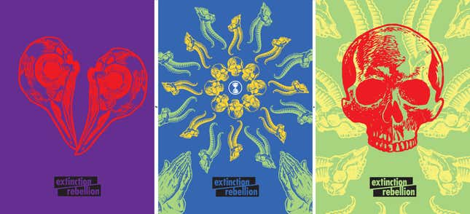

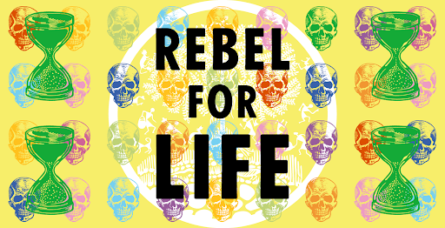

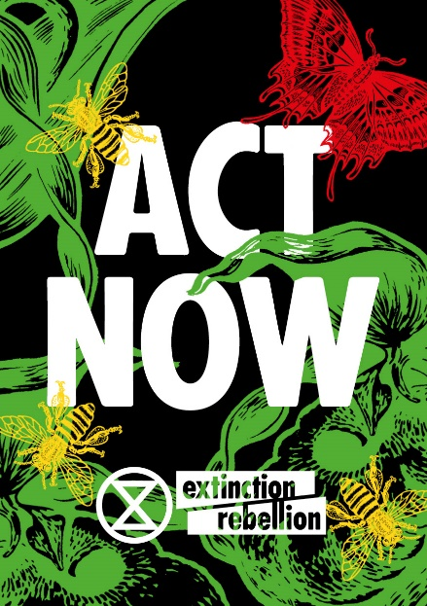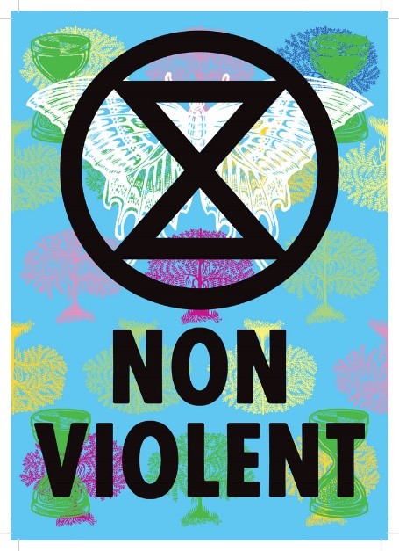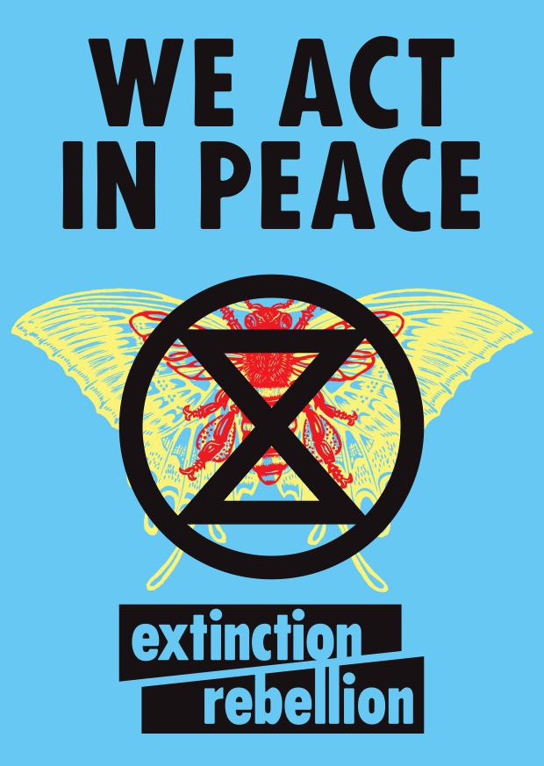

- Read about XR (above). Write these words on the board: ‘non violent’ ‘civil disobedience’ and ‘disruptive tactics’. Can pupils explain what these phrases mean in their own words, based on the context. Write explanations of these phrases together.

- Look at images or videos of the groups within XR who embody certain ‘personalities’. Below are the ‘Red Rebels’ and ‘Discobedience’.

- Use the graphic pack on the XR website to create your own posters- these are downloadable. You could print and collage, or create on the PC. Pupils’ posters can say anything they care about.

- Design a ‘personality’ that students could inhabit, like the Red Rebels or Discobedience (see below).

Red Rebels
Dressed in red, they move silently. They do not speak. They represent the blood that all species share. They bear witness to humanity’s destruction.

More info: https://redrebelbrigade.com/

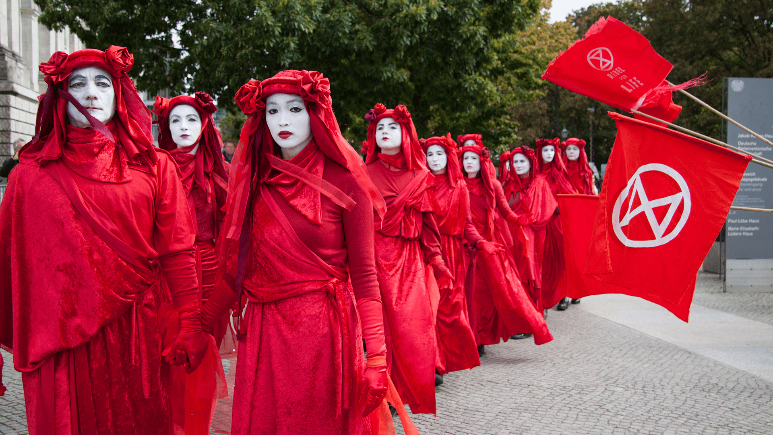

Discobedience (Disco- bedience)
Discobedience are dance troupes who perform flash mobs to raise awareness of the climate and ecological crisis. They are found in the UK, Italy, Spain, Australia, New Zealand and other countries. Anyone is welcome to join a discobedience dance flash mob, although the key organisers are usually dancers or performers.

Watch this video of a Discobedience flash mob in London: https://www.youtube.com/watch?v=pIDI4YfF34c
Try it yourself! https://www.youtube.com/watch?v=d8AO8vhhX3U

