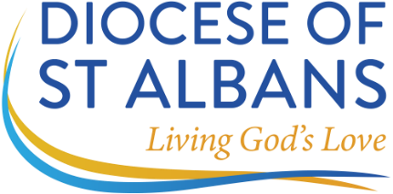 ARCHDEACONRY
OF HERTFORD

DEANERY __________________________________________________________________ PARISH ___________________________________________________________________

CERTIFICATE OF ELECTION

VISITATIONS 2026

To be signed by the chair of the annual meeting for the election of churchwardens 2026

Churchwarden 1

The Diocese of St Albans would like to hold your name, address, appointment details and such other data as are required for the diocese's administrative purposes and to enable communication with you. All data will be held in the secure Diocesan database and removed once you no longer hold any positions.

Diocesan Online Directory: Under the Data Protection Act and GDPR, we have to require you every year to complete and tick each box below to give permission to publish information about you on the Diocesan online directory.

Title ________ Full name (block letters please) ________________________________________________
Full postal address (including post code) _______________________________________________

________________________________________________________________________________

email ___________________________________________________________________________

home telephone_________________________ mobile no_________________________

Signed _____________________________________________ Dated ______________________________

Are you replacing a warden that has stepped down yes / no

Name of former warden _____________________________________________ (please print)

pto
Churchwarden 2
The Diocese of St Albans would like to hold your name, address, appointment details and such other data as are required for the diocese's administrative purposes and to enable communication with you. All data will be held in the secure Diocesan database and removed once you no longer hold any positions.

Diocesan Online Directory: Under the Data Protection Act and GDPR, we have to require you every year to complete and tick each box below to give permission to publish information about you on the Diocesan online directory.

Title ________ Full name (block letters please) ________________________________________________
Full postal address (including post code) _______________________________________________

________________________________________________________________________________

email ___________________________________________________________________________

home telephone_________________________ mobile no_________________________

Signed _____________________________________________ Dated ______________________________

Are you replacing a warden that has stepped down yes / no

Name of former warden _____________________________________________ (please print)

I CERTIFY THAT the aforementioned were duly elected Churchwardens of the above Parish at a meeting held pursuant to Section 2 of the Churchwardens (Appointment and Resignation) Measure 1964.

(signed) CHAIR __________________________ Dated ______________________________

Please print your name: ________________________________

Please return this form, duly completed, within SEVEN days of your meeting (including when no churchwardens have been elected) to:

The Archdeacon of Hertford’s Office
Glebe House
St Mary’s Lane
Hertingfordbury
Hertford
SG14 2LE

Scanned completed forms can be sent direct to archdhertpa@stalbans.anglican.org.

Further information concerning GDPR Regulations please visit the following link to view the diocesan privacy policy: Privacy Policy - The Diocese of St Albans
Please return form by the 2nd of June 2026 March 2026

