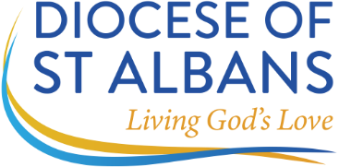
Archdeaconry of Hertford
VISITATIONS 2026

DEANERY: PARISH:

Visitation on Wednesday 20 May 2026 at St Catherine & St Paul’s Pauls Lane, Hoddesdon EN11 8TR at 7.30pm

Number of churchwardens attending: Number of guests attending:

Churchwardens attending (names):

Visitation on Thursday 11 June 2026 at the St Barnabas Centre, Church Lane, Thorley, CM23 4BE at 3pm

Number of churchwardens attending: Number of guests attending:

Churchwardens attending (names):

Visitation on Monday 29 June 2026 at Christ Church, New Road, Ware SG12 7BS at 7.30pm

Number of churchwardens attending: Number of guests attending:

Churchwardens attending (names):

Please return this form by post or email to the Archdeacon of Hertford’s office:
Glebe House, St Mary’s Lane, Hertingfordbury, Hertford SG14 2LE or
email: archdhertpa@stalbans.anglican.org

March 2026

